Simulating Camera Calibration Using Brown’s Radial Distortion Model

# Introduction

Camera calibration is a necessary step in analyzing camera-captured images. *Effects* such as unnatural, depths, compression, or stretching of an image occur as an unavoidable by product of current technology – in particular the type of lens utilized in the capture of the image [1]. Radial distortions are one of the possible effects an engineer tackles in these images; Brown’s Radial Lens Distortion Model (BRLDM) looks to adjust effected images and make them appear more naturally to the human persevere[1]. The BRLDM can be expressed through the following system of equations[2]:

|  |  |
| --- | --- |
|  | Eq. 1 |

where

|  |  |
| --- | --- |
| $$r=\sqrt{x_{n}^{2}+y_{n}^{2}}$$ | Eq. 2 |
| $$x_{n}=x-x_{c}$$ | Eq. 3 |
| $$y_{n}=y-y_{c}$$ | Eq. 4 |

and $n$, $d$, and $c$ represent normalized, distorted, and center values respectively.

Throughout this paper a sample image from a video game will be used as a benchmark for the artificial image distortion and undistortion algorithms that have been programmed in a Jupyter Notebook [2]. To highlight the different effects of radial distortion, *pincushion* and *barrel* distortions will be compared to $k$-values used in equation (1), and noting the performance of the primary undistortion in the case of only using $k_{1}$, $k_{1}$ and $k_{2}$, and finally all three $k$-values. By doing so, a high-level guideline will be generated to predict the sign (positive or negative) of the $k$-values when an engineering applies these algorithms in practice.

Moreover, qualitative and quantitative comparison between two undistortion algorithms will be done – one algorithm serves as an approximation in cases of small distortion and another that depends on heavy computational power and numerical solution methods to solve non-linear systems which are inherently difficult and sometimes unreliable to solve. The paper will conclude with a discussion on the real-world applications of image distortions as a whole and where radial lens distortions are most prominent.

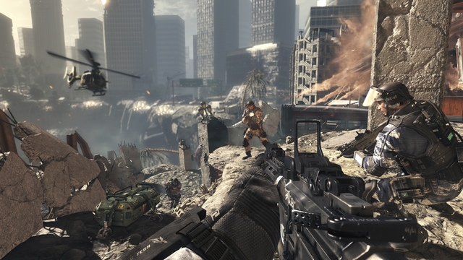

Figure 1: Benchmark image that will primarily be analyzed in this paper.

* Quick statement for the motivation of camera calibration
* Present brown’s radial distortion model
* Summarize what will be covered

# [Artificial Image Distortion](http://localhost:8888/lab#Artifical-Image-Distortion)

Placeholder

# I[mage Correction: Undistorting Images](http://localhost:8888/lab#Image-Correction:-Undistorting-Images)

Placeholder

# Real-World Implications

Placeholder

# References

|  |  |
| --- | --- |
| [1] | M. S. Banks, E. A. Cooper and E. A. Piazza, "Camera Focal Length and the Perception of Pictures," US National Library of Medicine National Institutes of Health, 1 January 2014. [Online]. Available: https://www.ncbi.nlm.nih.gov/pmc/articles/PMC4114730/. [Accessed 8 April 2020]. |

1. The idea of perception versus reality is an interesting, yet out of scope topic for purposed of this paper.
2. It should be noted that the presented model is not complete, it assumed there is no tangential distortions, which will briefly be discussed later.